NCU Off-Campus Housing Information
- photos
 |  |  | 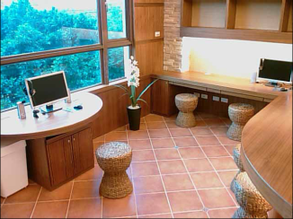
Address： | No.12, Shuanglian Sec. 2, Minzu Rd., Pingzhen City, Taoyuan County 324
Contact Info： | Ms. WANG (王麗惠) 0936-166-147
Apartment Type：room |  | Size：missed
Rent：$7,000 per month
utilities not included
Deposit：equal to 2-month rent |  | Lease：Required
- Security System Rentals
■Access Control □Fire EX. ■Emergency Light ■Monitoring System

- Amenities
■water heater ■TV ■Refrigerator ■Air-Conditioner ■Clothes Closet ■Bedstead
□Bookshelves ■Desk & Chair □Desk Lamp ■Cable TV □Telephone
□Windows

- Public Facilities
■Clothes Drying Field □Parking Spaces for Scooters □Parking Lot/Garage
□Elevator □Common Room ■Water Dispenser
■Washing Machine □Spin Dryer □Tumble Dryer ■kitchen

