NCU Off-Campus Housing Information
- photos
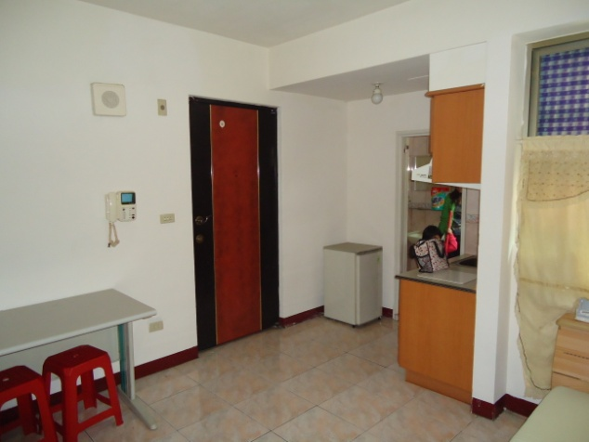 |  |  | 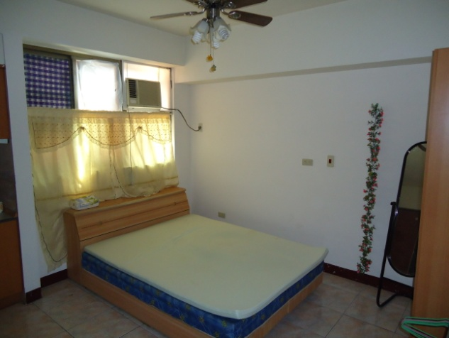
Address： | 2F., No.30, Ln. 369, Zhongyang Rd., Pingzhen City, Taoyuan County 324
Contact Info： | Ms. KAO (高綉琴) 02-2927-2092
Apartment Type：studio |  | Size：355 Sq Ft
Rent：$6,000 per month
utilities not included
Deposit：equal to 2-month rent |  | Lease：Required
- Security System Rentals
□Access Control □Fire EX. □Emergency Light □Monitoring System

- Amenities
■water heater ■TV ■Refrigerator ■Air-Conditioner ■Clothes Closet ■Bedstead
□Bookshelves ■Desk & Chair □Desk Lamp □Cable TV □Telephone
□Windows

- Public Facilities
□Clothes Drying Field ■Parking Spaces for Scooters □Parking Lot/Garage
□Elevator □Common Room ■Water Dispenser
■Washing Machine □Spin Dryer ■Tumble Dryer □kitchen

