NCU Off-Campus Housing Information
- photos
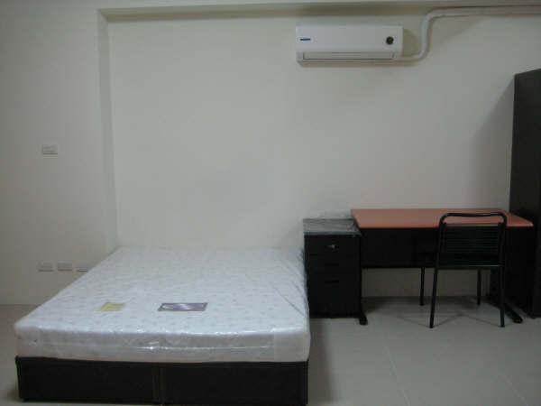 |  |  | 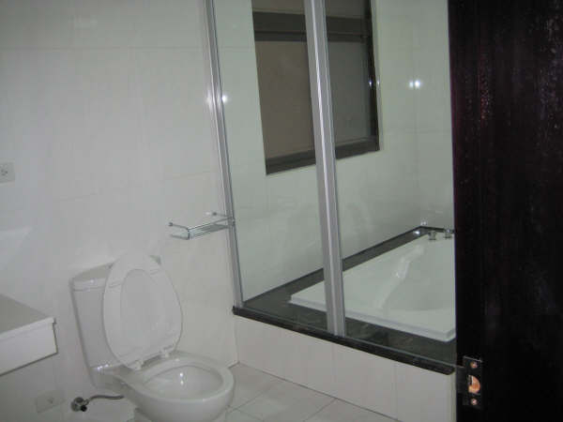
Address： | No.3, Zhengguang 2nd St., Zhongli City, Taoyuan County 320
Contact Info： | Ms. HUANG (黃) 0968-840-822
Apartment Type：studio, room |  | Size：missed
Rent：$7,500(studio) / $3,800-4,200(room) per month
utilities not included
Deposit：equal to 2-month rent |  | Lease：missed
- Security System Rentals
□Access Control □Fire EX. □Emergency Light ■Monitoring System

- Amenities
■water heater □TV ■Refrigerator ■Air-Conditioner ■Clothes Closet ■Bedstead
□Bookshelves ■Desk & Chair □Desk Lamp □Cable TV □Telephone
□Windows

- Public Facilities
□Clothes Drying Field ■Parking Spaces for Scooters ■Parking Lot/Garage
□Elevator □Common Room □Water Dispenser
■Washing Machine □Spin Dryer □Tumble Dryer ■kitchen

