NCU Off-Campus Housing Information
- photos
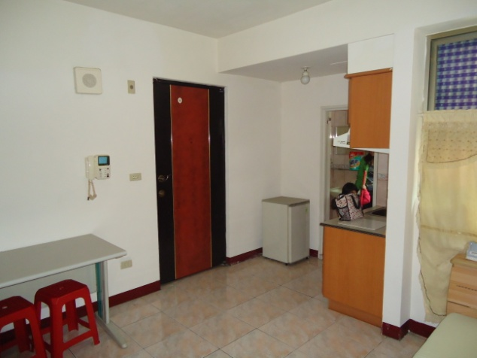 |  |  | 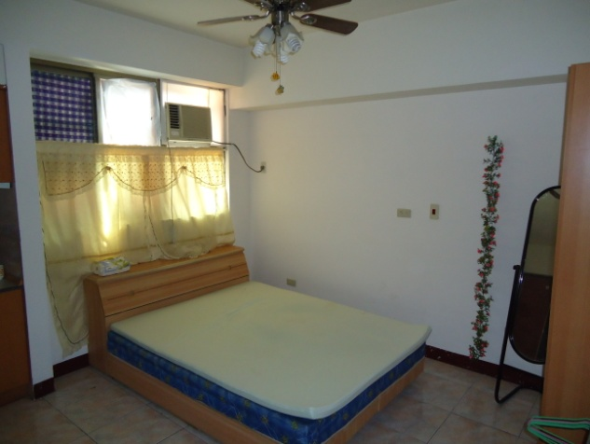
Address： | No.243, Yanping Rd., Zhongli City, Taoyuan County 320
Contact Info： | Ms. LU (魯秀明) 0988-832-190
Apartment Type：apartment, studio |  | Size：320 Sq Ft
Rent：$6,000 per month
utilities not included
Deposit：$6,000 |  | Lease：missed
- Security System Rentals
■Access Control ■Fire EX. ■Emergency Light ■Monitoring System

- Amenities
■water heater ■TV ■Refrigerator ■Air-Conditioner ■Clothes Closet ■Bedstead
□Bookshelves ■Desk & Chair □Desk Lamp ■Cable TV □Telephone
■Windows

- Public Facilities
■Clothes Drying Field ■Parking Spaces for Scooters □Parking Lot/Garage
■Elevator ■Common Room ■Water Dispenser
■Washing Machine □Spin Dryer □Tumble Dryer ■kitchen

