NCU Off-Campus Housing Information
- photos
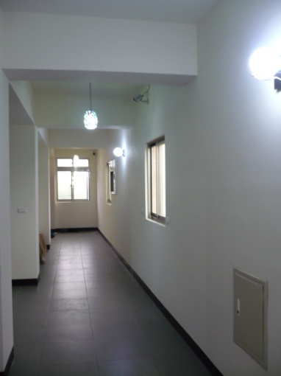 |  |  | 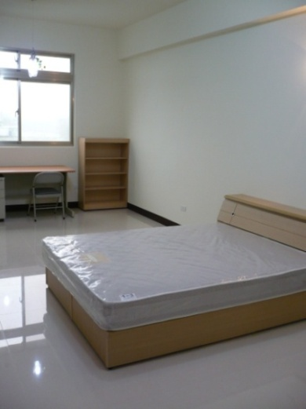
Address： | No.27, Aly. 51, Zhongyang Rd., Pingzhen City, Taoyuan County 324
Contact Info： | Mr. LO (羅聲) 0986-108-396
Apartment Type：missed |  | Size：missed
Rent：$6,000 / month
utilities not included
Deposit：equal to 2-month rent |  | Lease：missed
- Security System Rentals
■Access Control ■Fire EX. ■Emergency Light ■Monitoring System

- Amenities
■water heater □TV □Refrigerator ■Air-Conditioner ■Clothes Closet ■Bedstead
□Bookshelves ■Desk & Chair □Desk Lamp ■Cable TV □Telephone
□Windows

- Public Facilities
■Clothes Drying Field ■Parking Spaces for Scooters □Parking Lot/Garage
□Elevator □Common Room ■Water Dispenser
■Washing Machine □Spin Dryer ■Tumble Dryer □kitchen

