NCU Off-Campus Housing Information
- photos
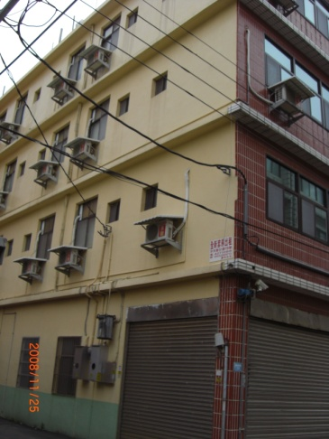 |  |  | 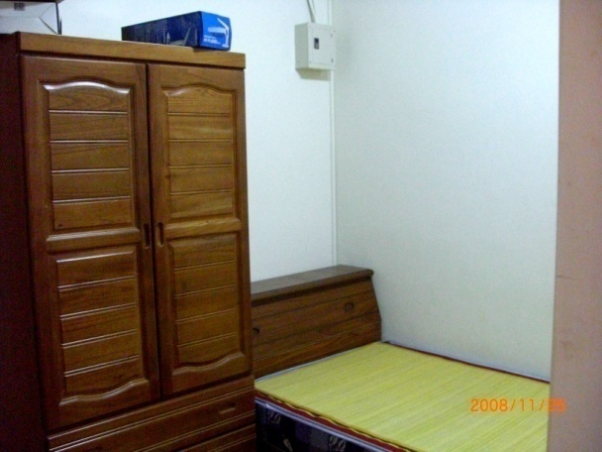
Address： | No.19, Aly. 51, Zhongyang Rd., Pingzhen City, Taoyuan County 324
Contact Info： | Mr. CHAN (詹前彬) 03-427-1088 / 0932-369-713
Apartment Type：missed |  | Size：missed
Rent：$24,000 / semester
utilities not included
Deposit：$5,000 |  | Lease：missed
- Security System Rentals
□Access Control ■Fire EX. ■Emergency Light ■Monitoring System

- Amenities
■water heater ■TV ■Refrigerator ■Air-Conditioner ■Clothes Closet ■Bedstead
□Bookshelves ■Desk & Chair □Desk Lamp ■Cable TV □Telephone
□Windows

- Public Facilities
■Clothes Drying Field ■Parking Spaces for Scooters ■Parking Lot/Garage
□Elevator □Common Room ■Water Dispenser
■Washing Machine □Spin Dryer ■Tumble Dryer □kitchen

