NCU Off-Campus Housing Information
- photos
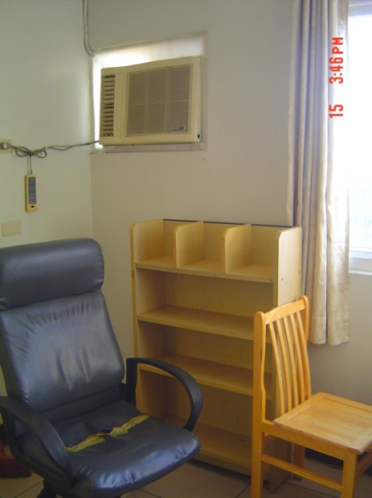 |  |  | 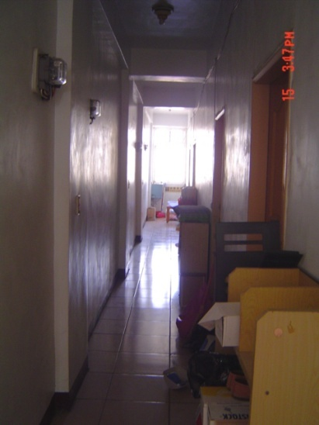
Address： | No.151, Zhongyang Rd., Pingzhen City, Taoyuan County 324
Contact Info： | Mr. Liao (廖房東) 0911-114-965
Apartment Type：room |  | Size：142-284 Sq Ft
Rent：$28,000 / semester
utilities not included
Deposit：$5,000 |  | Lease：required
- Security System Rentals
□Access Control ■Fire EX. ■Emergency Light □Monitoring System

- Amenities
■water heater □TV ■Refrigerator ■Air-Conditioner ■Clothes Closet ■Bedstead
□Bookshelves ■Desk & Chair □Desk Lamp □Cable TV □Telephone
□Windows

- Public Facilities
■Clothes Drying Field ■Parking Spaces for Scooters □Parking Lot/Garage
□Elevator □Common Room ■Water Dispenser
■Washing Machine □Spin Dryer ■Tumble Dryer □kitchen

