NCU Off-Campus Housing Information
- photos
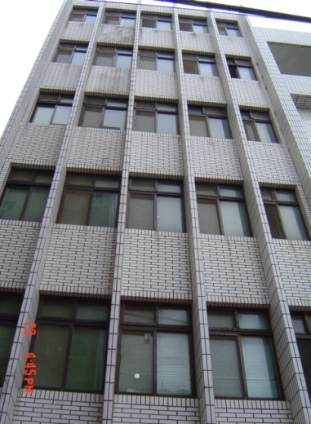 |  |  | 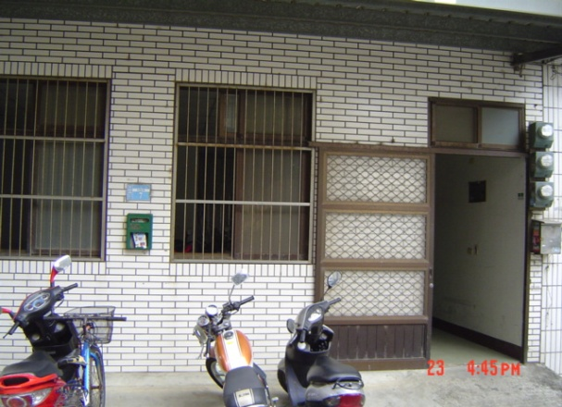
Address： | No.7, Ln. 119, Zhongyang Rd., Pingzhen City, Taoyuan County 324
Contact Info： | Mr. LIU (劉阿坤) 0935-969-624 / 03-490-0060
Apartment Type：studio |  | Size：missed
Rent：$20,000 for 6-month
utilities not included
Deposit：$3,000 |  | Lease：missed
- Security System Rentals
□Access Control ■Fire EX. ■Emergency Light □Monitoring System

- Amenities
■water heater ■TV ■Refrigerator ■Air-Conditioner ■Clothes Closet ■Bedstead
□Bookshelves ■Desk & Chair □Desk Lamp ■Cable TV ■Telephone
□Windows

- Public Facilities
■Clothes Drying Field ■Parking Spaces for Scooters □Parking Lot/Garage
□Elevator □Common Room ■Water Dispenser
■Washing Machine □Spin Dryer ■Tumble Dryer □kitchen

