NCU Off-Campus Housing Information
- photos
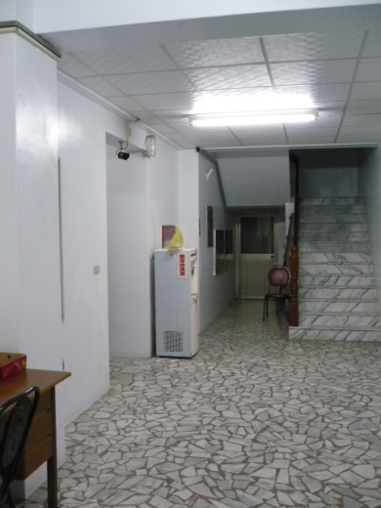 |  |  | 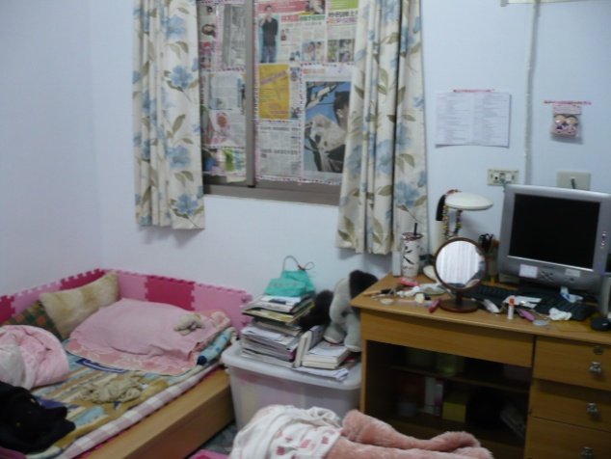
Address： | No.77, Zhongyang Rd., Zhongli City, Taoyuan County 320
Contact Info： | Mr. YU (游玉勳) 03-490-6107
Apartment Type：studio |  | Size：missed
Rent：missed

Deposit：missed |  | Lease：missed
- Security System Rentals
■Access Control ■Fire EX. ■Emergency Light ■Monitoring System

- Amenities
■water heater □TV □Refrigerator ■Air-Conditioner ■Clothes Closet □Bedstead
□Bookshelves ■Desk & Chair □Desk Lamp ■Cable TV □Telephone
□Windows

- Public Facilities
■Clothes Drying Field ■Parking Spaces for Scooters □Parking Lot/Garage
■Elevator ■Common Room ■Water Dispenser
□Washing Machine □Spin Dryer ■Tumble Dryer □kitchen

