NCU Off-Campus Housing Information
- photos
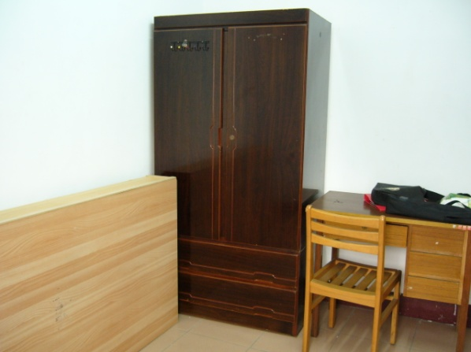 |  |  | 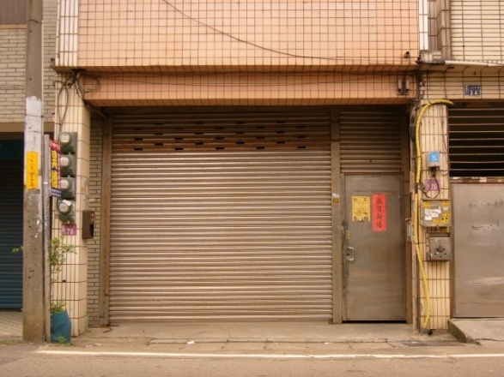
Address： | No.76, Zhongyang Rd., Zhongli City, Taoyuan County 320
Contact Info： | Ms. YANG (楊麗華) 0913-358-791
Apartment Type：studio |  | Size：142 Sq Ft
Rent：$18,000 for 6-month
utilities not included
Deposit：$3,000 |  | Lease：missed
- Security System Rentals
□Access Control ■Fire EX. ■Emergency Light □Monitoring System

- Amenities
■water heater □TV □Refrigerator ■Air-Conditioner ■Clothes Closet ■Bedstead
□Bookshelves ■Desk & Chair □Desk Lamp ■Cable TV □Telephone
□Windows

- Public Facilities
■Clothes Drying Field ■Parking Spaces for Scooters □Parking Lot/Garage
□Elevator □Common Room ■Water Dispenser
■Washing Machine □Spin Dryer ■Tumble Dryer □kitchen

