NCU Off-Campus Housing Information
- photos
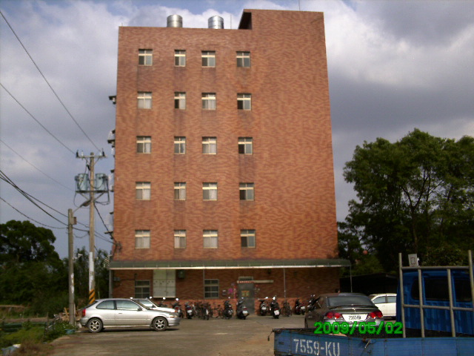 |  |  | 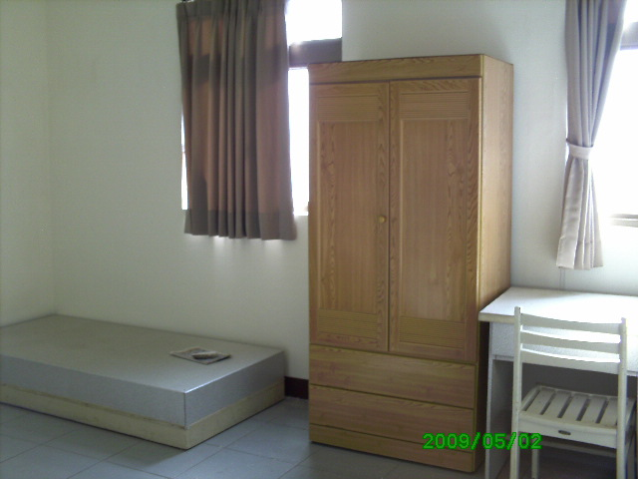
Address： | No.46, Zhongyang Rd., Zhongli City, Taoyuan County 320
Contact Info： | Mrs.HU (胡太太) 03-4907-799 / 0963-264-657
Apartment Type：missed |  | Size：missed
Rent：$22,000 for 6-month

Deposit：missed |  | Lease：missed
- Security System Rentals
■Access Control ■Fire EX. ■Emergency Light ■Monitoring System

- Amenities
■water heater □TV □Refrigerator ■Air-Conditioner ■Clothes Closet ■Bedstead
□Bookshelves ■Desk & Chair □Desk Lamp ■Cable TV □Telephone
□Windows

- Public Facilities
■Clothes Drying Field ■Parking Spaces for Scooters □Parking Lot/Garage
■Elevator □Common Room ■Water Dispenser
■Washing Machine □Spin Dryer ■Tumble Dryer □kitchen

