NCU Off-Campus Housing Information
- photos
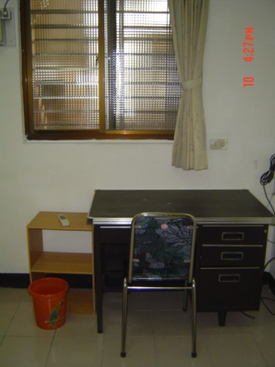 |  |  | 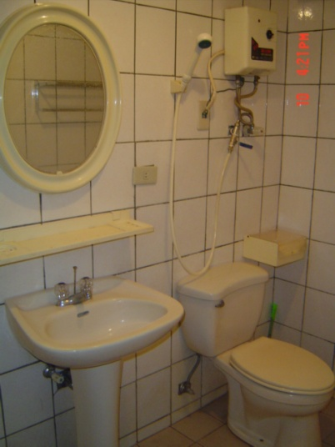
Address： | No.36, Ln. 232, Zhongyang Rd., Zhongli City, Taoyuan County 320
Contact Info： | Mr. HUANG(黃俊維) 0934-363-927 / 0937-170-366
Apartment Type：studio |  | Size：missed
Rent：$19,000 / semester
utilities not included
Deposit：$3,000 |  | Lease：required
- Security System Rentals
■Access Control ■Fire EX. ■Emergency Light ■Monitoring System

- Amenities
■water heater □TV □Refrigerator ■Air-Conditioner ■Clothes Closet ■Bedstead
□Bookshelves ■Desk & Chair □Desk Lamp ■Cable TV ■Telephone
□Windows

- Public Facilities
■Clothes Drying Field ■Parking Spaces for Scooters □Parking Lot/Garage
■Elevator □Common Room ■Water Dispenser
■Washing Machine □Spin Dryer ■Tumble Dryer □kitchen

