NCU Off-Campus Housing Information
- photos
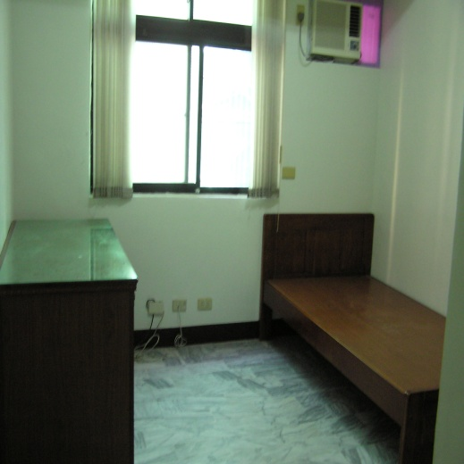 |  |  | 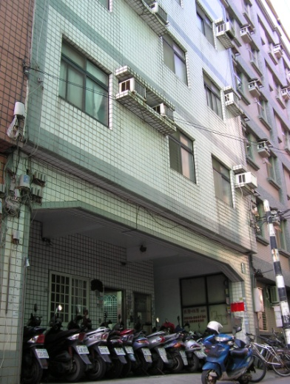
Address： | No.23, Ln. 232, Zhongyang Rd., Zhongli City, Taoyuan County 320
Contact Info： | Mr. CHUANG(莊先生) 0932-268-730
Apartment Type：studio, room |  | Size：missed
Rent：$20,000 / semester
utilities not included
Deposit：missed |  | Lease：missed
- Security System Rentals
□Access Control □Fire EX. □Emergency Light □Monitoring System

- Amenities
■water heater □TV □Refrigerator ■Air-Conditioner ■Clothes Closet ■Bedstead
□Bookshelves ■Desk & Chair □Desk Lamp ■Cable TV □Telephone
□Windows

- Public Facilities
■Clothes Drying Field □Parking Spaces for Scooters □Parking Lot/Garage
□Elevator □Common Room □Water Dispenser
□Washing Machine □Spin Dryer □Tumble Dryer □kitchen

