NCU Off-Campus Housing Information
- photos
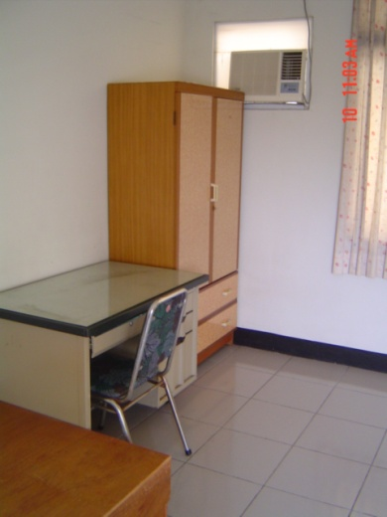 |  |  | 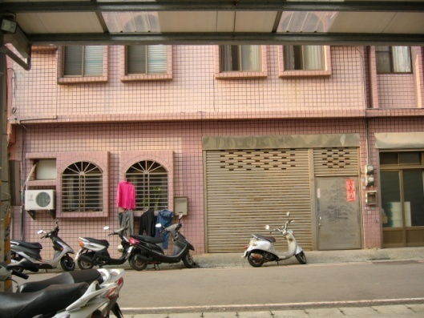
Address： | No.7, Ln. 232, Zhongyang Rd., Zhongli City, Taoyuan County 320
Contact Info： | Ms. WU(吳秋蘭) 0975-125-623
Apartment Type：studio, room |  | Size：missed
Rent：$23,000 / semester
utilities not included
Deposit：$6,500 |  | Lease：required
- Security System Rentals
□Access Control ■Fire EX. ■Emergency Light ■Monitoring System

- Amenities
■water heater □TV □Refrigerator ■Air-Conditioner ■Clothes Closet ■Bedstead
□Bookshelves ■Desk & Chair □Desk Lamp ■Cable TV ■Telephone
□Windows

- Public Facilities
■Clothes Drying Field ■Parking Spaces for Scooters ■Parking Lot/Garage
■Elevator ■Common Room ■Water Dispenser
■Washing Machine ■Spin Dryer ■Tumble Dryer □kitchen

