NCU Off-Campus Housing Information
- photos
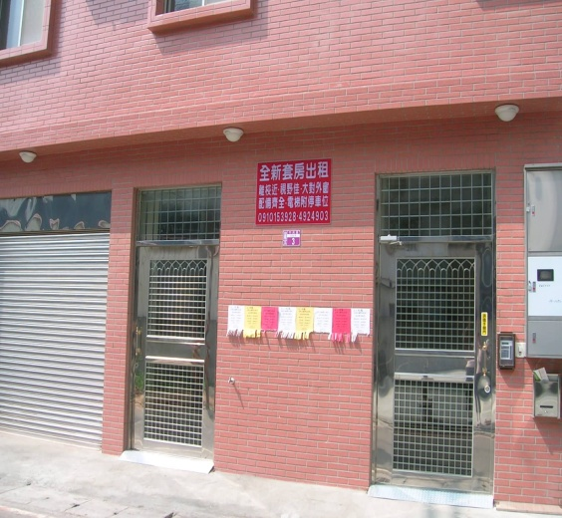 |  |  | 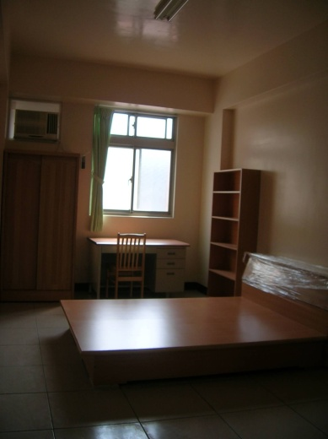
Address： | No.3, Ln. 232, Zhongyang Rd., Zhongli City, Taoyuan County 320
Contact Info： | Mr. LIN(林有清) 03-492-4993 / 03-492-4903 / 0910-153-928
Apartment Type：missed |  | Size：missed
Rent：$20,000 / semester
utilities not included
Deposit：$5,000 |  | Lease：not required
- Security System Rentals
□Access Control □Fire EX. □Emergency Light □Monitoring System

- Amenities
■water heater □TV □Refrigerator ■Air-Conditioner ■Clothes Closet ■Bedstead
■Bookshelves ■Desk & Chair □Desk Lamp □Cable TV □Telephone
□Windows

- Public Facilities
□Clothes Drying Field ■Parking Spaces for Scooters □Parking Lot/Garage
■Elevator □Common Room ■Water Dispenser
■Washing Machine □Spin Dryer □Tumble Dryer □kitchen

