NCU Off-Campus Housing Information
- photos
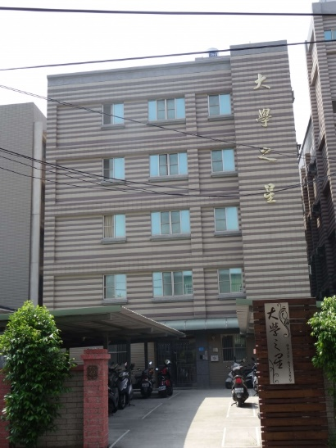 |  |  | 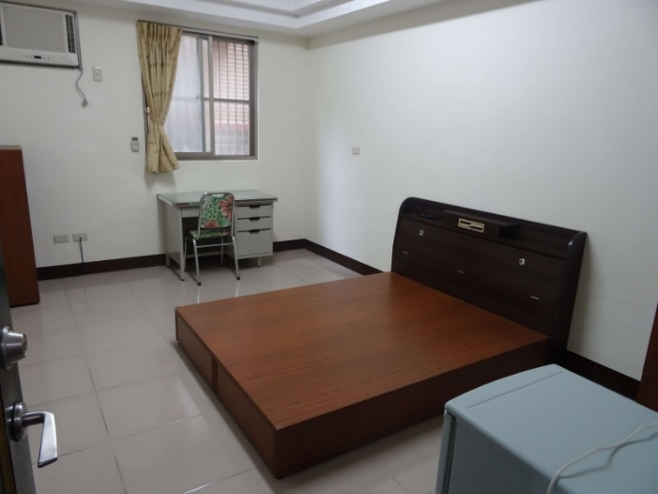
Address： | No.23, Zhongyang Rd., Zhongli City, Taoyuan County 320
Contact Info： | Mr. LUO (羅房東) 0928-651-259
Apartment Type：studio, room |  | Size：142-284 Sq Ft
Rent：$28,000 / semester
utilities not included
Deposit：equal to 2-month rent |  | Lease：Required
- Security System Rentals
■Access Control ■Fire EX. ■Emergency Light ■Monitoring System

- Amenities
■water heater □TV □Refrigerator ■Air-Conditioner ■Clothes Closet ■Bedstead
□Bookshelves ■Desk & Chair □Desk Lamp ■Cable TV □Telephone
□Windows

- Public Facilities
■Clothes Drying Field ■Parking Spaces for Scooters □Parking Lot/Garage
□Elevator ■Common Room ■Water Dispenser
■Washing Machine □Spin Dryer ■Tumble Dryer □kitchen

