NCU Off-Campus Housing Information
- photos
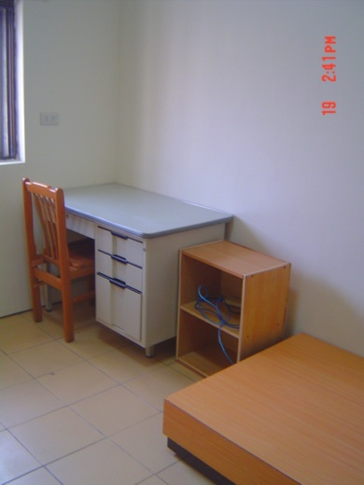 |  |  | 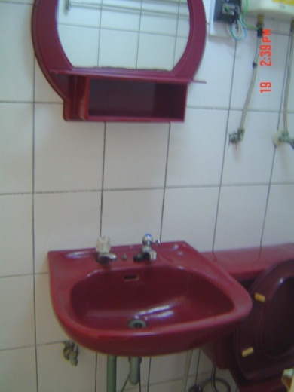
Address： | No.8, Ln. 216, Zhongyang Rd., Zhongli City, Taoyuan County 320
Contact Info： | Mr. Chen(陳房東) 0972-280-291
Apartment Type：studio |  | Size：142 Sq Ft
Rent：$20,000 / semester
utilities not included
Deposit：$5,000 |  | Lease：required
- Security System Rentals
□Access Control ■Fire EX. □Emergency Light ■Monitoring System

- Amenities
■water heater □TV □Refrigerator ■Air-Conditioner ■Clothes Closet ■Bedstead
□Bookshelves ■Desk & Chair □Desk Lamp ■Cable TV □Telephone
□Windows

- Public Facilities
□Clothes Drying Field □Parking Spaces for Scooters □Parking Lot/Garage
□Elevator □Common Room ■Water Dispenser
■Washing Machine □Spin Dryer □Tumble Dryer □kitchen

