NCU Off-Campus Housing Information
- photos
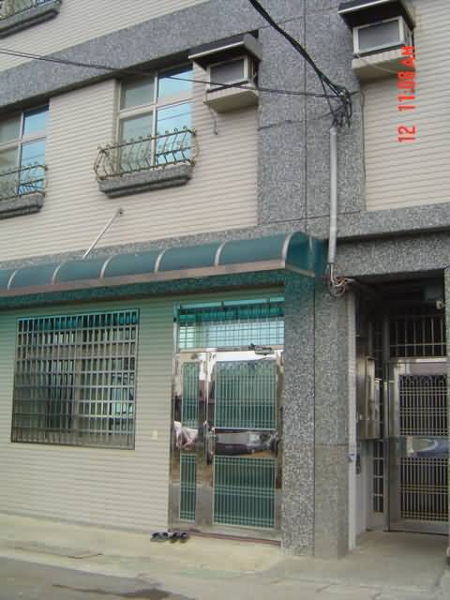 |  |  | 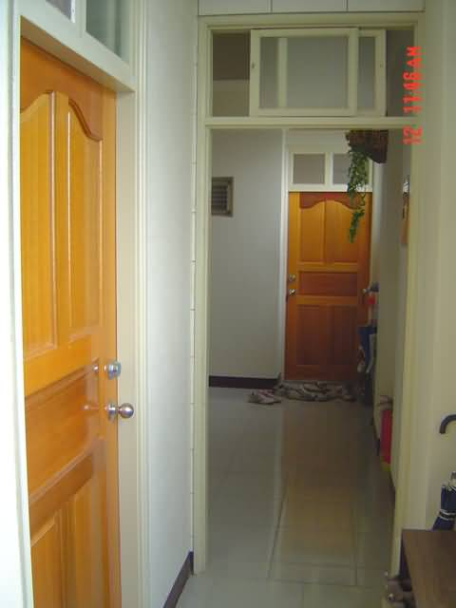
Address： | No.25, Ln. 216, Zhongyang Rd., Zhongli City, Taoyuan County 320
Contact Info： | Mr. CHIU(邱中和) 03-498-983 / 0938-627-600
Apartment Type：missed |  | Size：missed
Rent：20,000-25,000 for 6-month
utilities not included
Deposit：missed |  | Lease：missed
- Security System Rentals
□Access Control □Fire EX. □Emergency Light □Monitoring System

- Amenities
■water heater □TV □Refrigerator ■Air-Conditioner ■Clothes Closet ■Bedstead
□Bookshelves ■Desk & Chair □Desk Lamp □Cable TV □Telephone
□Windows

- Public Facilities
□Clothes Drying Field ■Parking Spaces for Scooters □Parking Lot/Garage
■Elevator □Common Room ■Water Dispenser
■Washing Machine ■Spin Dryer □Tumble Dryer □kitchen

