NCU Off-Campus Housing Information
- photos
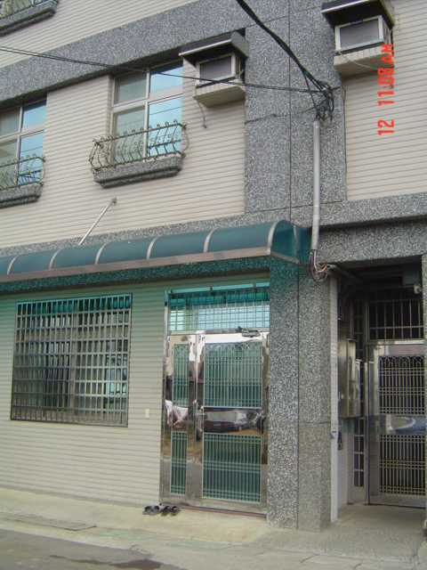 |  |  | 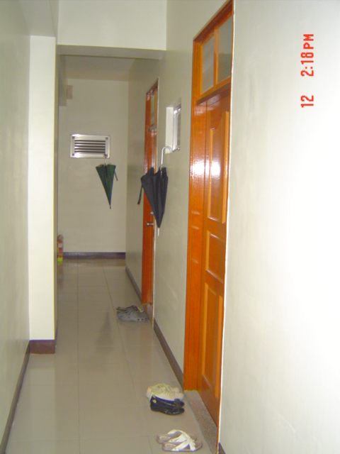
Address： | No.23, Ln. 216, Zhongyang Rd., Zhongli City, Taoyuan County 320
Contact Info： | Mr. WU(吳更新) 03-490-0507 / 0952-291-411
Apartment Type：missed |  | Size：missed
Rent：missed
utilities not included
Deposit：missed |  | Lease：required
- Security System Rentals
■Access Control ■Fire EX. □Emergency Light □Monitoring System

- Amenities
■water heater □TV □Refrigerator ■Air-Conditioner ■Clothes Closet ■Bedstead
□Bookshelves ■Desk & Chair □Desk Lamp □Cable TV □Telephone
□Windows

- Public Facilities
□Clothes Drying Field □Parking Spaces for Scooters □Parking Lot/Garage
□Elevator □Common Room ■Water Dispenser
■Washing Machine ■Spin Dryer □Tumble Dryer □kitchen

