NCU Off-Campus Housing Information
- photos
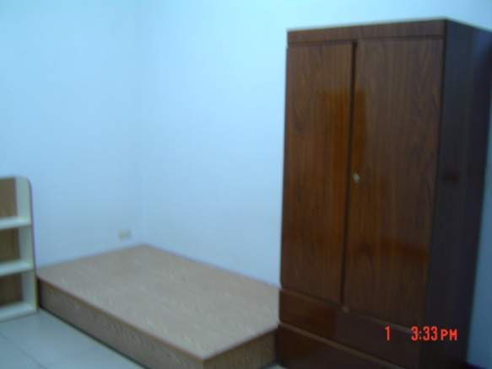 |  |  | 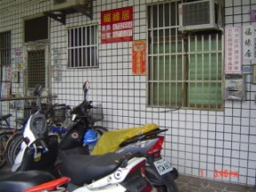
Address： | No.13, Ln. 216, Zhongyang Rd., Zhongli City, Taoyuan County 320
Contact Info： | Mr. Yang(楊房東) 0912-049-328
Apartment Type：studio |  | Size：142-213 Sq Ft
Rent：$18,000 / semester
utilities not included
Deposit：$5,000 |  | Lease：missed
- Security System Rentals
■Access Control ■Fire EX. ■Emergency Light ■Monitoring System

- Amenities
■water heater □TV □Refrigerator ■Air-Conditioner ■Clothes Closet ■Bedstead
■Bookshelves ■Desk & Chair □Desk Lamp ■Cable TV □Telephone
□Windows

- Public Facilities
■Clothes Drying Field ■Parking Spaces for Scooters ■Parking Lot/Garage
■Elevator □Common Room ■Water Dispenser
■Washing Machine ■Spin Dryer ■Tumble Dryer □kitchen

