NCU Off-Campus Housing Information
- photos
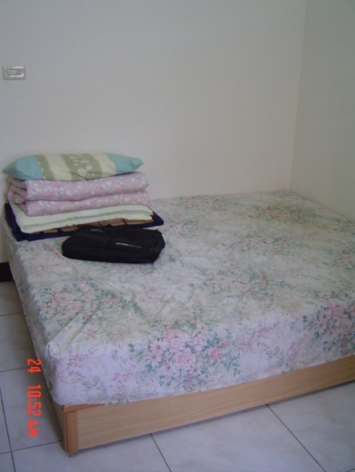 |  |  | 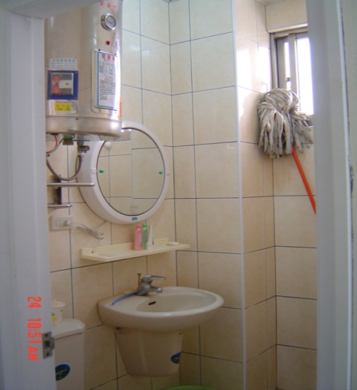
Address： | No.17, Ln. 168, Zhongyang Rd., Zhongli City, Taoyuan County 320
Contact Info： | Mr. CHAO (趙寄昆) 0968-490-403
Apartment Type：studio |  | Size：284-355 Sq Ft
Rent：$2,000 per month
utilities not included
Deposit：$2,500 |  | Lease：missed
- Security System Rentals
■Access Control ■Fire EX. ■Emergency Light ■Monitoring System

- Amenities
■water heater ■TV □Refrigerator ■Air-Conditioner ■Clothes Closet ■Bedstead
■Bookshelves ■Desk & Chair ■Desk Lamp ■Cable TV □Telephone
■Windows

- Public Facilities
■Clothes Drying Field ■Parking Spaces for Scooters □Parking Lot/Garage
■Elevator □Common Room ■Water Dispenser
■Washing Machine ■Spin Dryer ■Tumble Dryer □kitchen

