NCU Off-Campus Housing Information
- photos
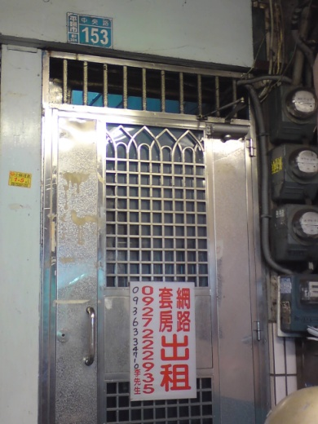 |  |  | 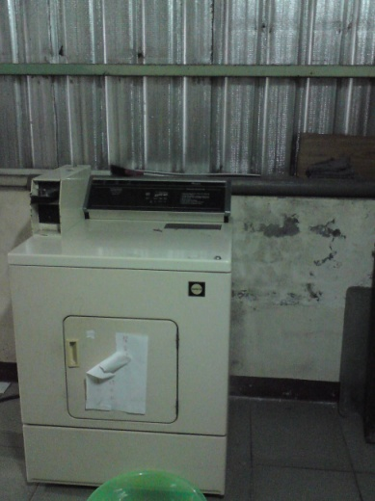
Address： | No.153, Zhongyang Rd., Zhongli City, Taoyuan County 324
Contact Info： | Ms. LIU(劉員妹) 0936-334-710 / 0927-222-935
Apartment Type：studio |  | Size：missed
Rent：$18,000 / semester
utilities not included
Deposit：missed |  | Lease：missed
- Security System Rentals
□Access Control ■Fire EX. ■Emergency Light □Monitoring System

- Amenities
■water heater □TV □Refrigerator ■Air-Conditioner □Clothes Closet ■Bedstead
□Bookshelves □Desk & Chair □Desk Lamp □Cable TV □Telephone
□Windows

- Public Facilities
□Clothes Drying Field □Parking Spaces for Scooters □Parking Lot/Garage
□Elevator □Common Room ■Water Dispenser
■Washing Machine □Spin Dryer □Tumble Dryer □kitchen

