NCU Off-Campus Housing Information
- photos
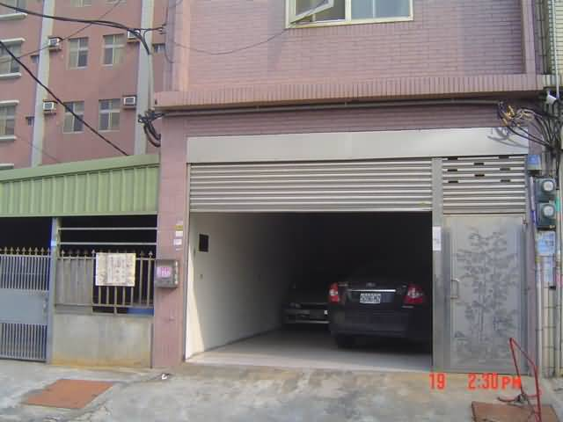 |  |  | 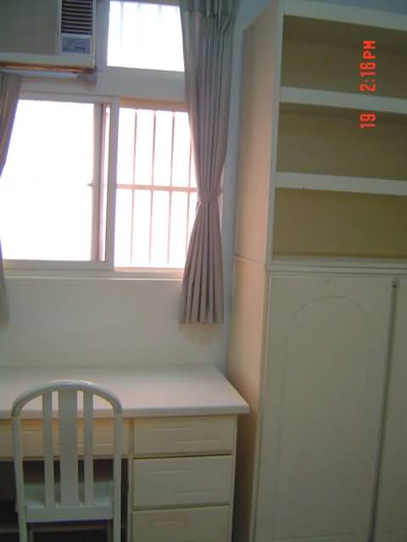
Address： | No.150, Zhongyang Rd., Zhongli City, Taoyuan County 324
Contact Info： | Mr. TSENG(曾玉鑑) 03-490-6290 / 0910-262-817
Apartment Type：missed |  | Size：missed
Rent： $18,000 / semester
utilities not included
Deposit：missed |  | Lease：missed
- Security System Rentals
□Access Control □Fire EX. □Emergency Light □Monitoring System

- Amenities
■water heater □TV □Refrigerator ■Air-Conditioner □Clothes Closet ■Bedstead
■Bookshelves ■Desk & Chair □Desk Lamp □Cable TV □Telephone
□Windows

- Public Facilities
□Clothes Drying Field ■Parking Spaces for Scooters □Parking Lot/Garage
□Elevator □Common Room ■Water Dispenser
■Washing Machine □Spin Dryer □Tumble Dryer □kitchen

