NCU Off-Campus Housing Information
- photos
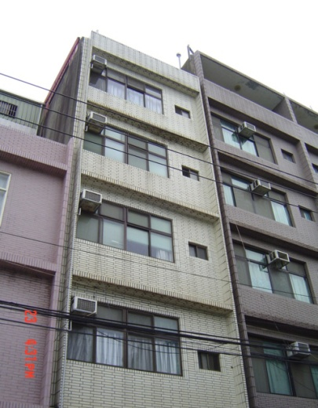 |  |  | 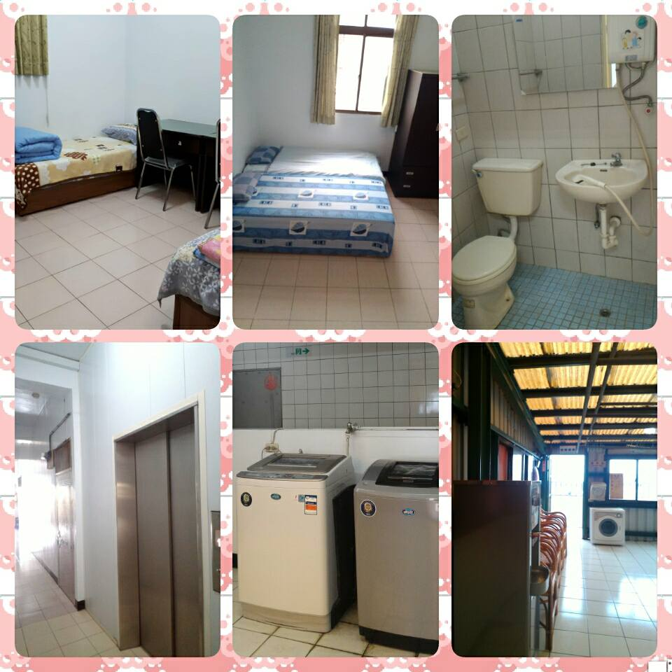
Address： | No.148, Zhongyang Rd., Zhongli City, Taoyuan County 324
Contact Info： | Mr. WU(吳文鈞) 03-490-6280 / 0921-847-202
Apartment Type：studio |  | Size：320-355 Sq Ft
Rent： $30,000 / semester
utilities not included
Deposit：$5,000 |  | Lease：Required
- Security System Rentals
□Access Control ■Fire EX. ■Emergency Light ■Monitoring System

- Amenities
■Water Heater □TV □Refrigerator ■Air-Conditioner ■Clothes Closet ■Bedstead
□Bookshelves ■Desk & Chair □Desk Lamp □Cable TV □Telephone
■Windows ■Internet/WiFi Access

- Public Facilities
■Clothes Drying Field ■Parking Spaces for Scooters □Parking Lot/Garage
■Elevator □Common Room ■Water Dispenser
■Washing Machine ■Spin Dryer ■Tumble Dryer □kitchen

