NCU Off-Campus Housing Information
- photos
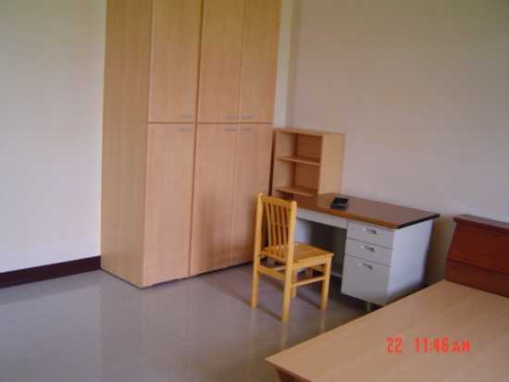 |  |  | 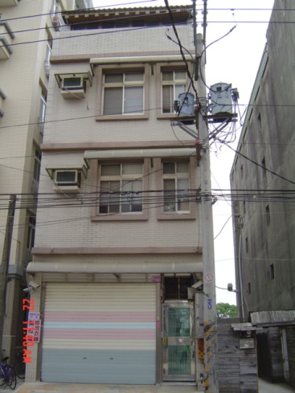
Address： | No.122, Zhongyang Rd., Zhongli City, Taoyuan County 320
Contact Info： | Mr. Peng(彭房東) 0926-534-328
Apartment Type：studio |  | Size：426 Sq Ft(max)
Rent：$26,000 / semester
utilities not included
Deposit：$5,000 |  | Lease：missed
- Security System Rentals
■Access Control ■Fire EX. ■Emergency Light ■Monitoring System

- Amenities
■water heater □TV □Refrigerator ■Air-Conditioner ■Clothes Closet ■Bedstead
■Bookshelves ■Desk & Chair □Desk Lamp ■Cable TV □Telephone
■Windows

- Public Facilities
■Clothes Drying Field ■Parking Spaces for Scooters □Parking Lot/Garage
□Elevator □Common Room ■Water Dispenser
■Washing Machine ■Spin Dryer ■Tumble Dryer □kitchen

