NCU Off-Campus Housing Information
- photos
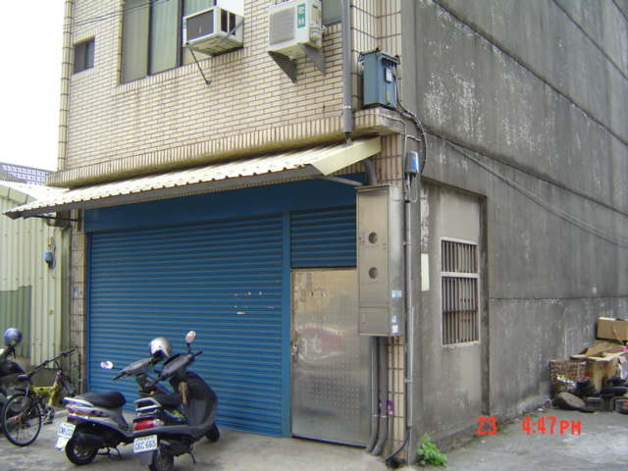 |  |  | 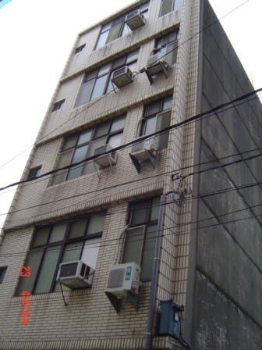
Address： | No.20, Ln. 119, Zhongyang Rd., Zhongli City, Taoyuan County 320
Contact Info： | missed 03-420-4208
Apartment Type：missed |  | Size：missed
Rent：$18,000 for 6-month
utilities not included
Deposit：$5,000 |  | Lease：missed
- Security System Rentals
□Access Control □Fire EX. □Emergency Light □Monitoring System

- Amenities
■water heater □TV □Refrigerator ■Air-Conditioner ■Clothes Closet ■Bedstead
□Bookshelves ■Desk & Chair □Desk Lamp ■Cable TV □Telephone
□Windows

- Public Facilities
■Clothes Drying Field ■Parking Spaces for Scooters □Parking Lot/Garage
□Elevator □Common Room ■Water Dispenser
■Washing Machine □Spin Dryer □Tumble Dryer □kitchen

