NCU Off-Campus Housing Information
- photos
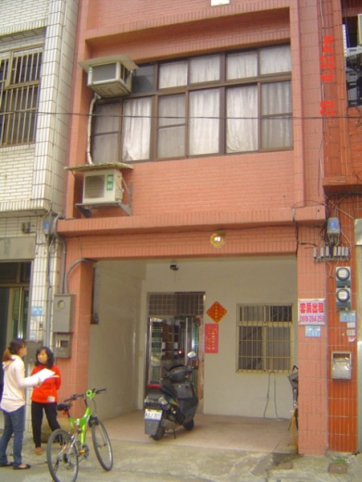
Address： | F3&4, No.11, Ln. 119, Zhongyang Rd., Zhongli City, Taoyuan County 320
Contact Info： | Mrs. LIN (林房東) 0919-264-259
Apartment Type：studio |  | Size：missed
Rent：$26,000 / semester
utilities not included
Deposit：$5,000 |  | Lease：missed
- Security System Rentals
□Access Control ■Fire EX. ■Emergency Light □Monitoring System

- Amenities
■water heater ■TV □Refrigerator ■Air-Conditioner ■Clothes Closet ■Bedstead
□Bookshelves ■Desk & Chair □Desk Lamp ■Cable TV □Telephone
□Windows

- Public Facilities
■Clothes Drying Field ■Parking Spaces for Scooters □Parking Lot/Garage
□Elevator □Common Room ■Water Dispenser
■Washing Machine □Spin Dryer ■Tumble Dryer □kitchen

