NCU Off-Campus Housing Information
- photos
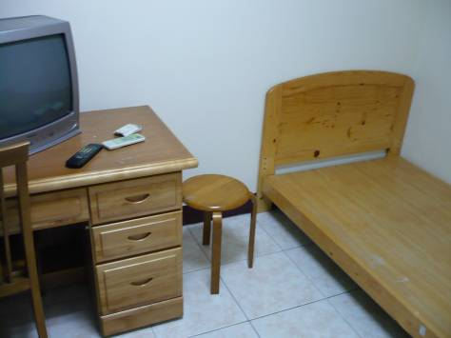 |  |  | 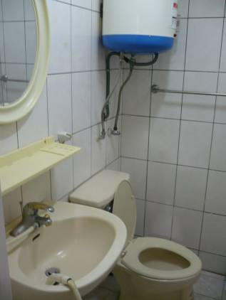
Address： | No.418, Wuxing Rd., Zhongli City, Taoyuan County 320
Contact Info： | Ms. PENG(澎玉珍) 03-490-2997
Apartment Type：studio |  | Size：142 Sq Ft
Rent： $21,000-22,000 for 6-month
utilities not included
Deposit：$5,000 |  | Lease：missed
- Security System Rentals
□Access Control ■Fire EX. ■Emergency Light ■Monitoring System

- Amenities
■water heater ■TV □Refrigerator ■Air-Conditioner ■Clothes Closet □Bedstead
□Bookshelves ■Desk & Chair □Desk Lamp ■Cable TV □Telephone
□Windows

- Public Facilities
■Clothes Drying Field ■Parking Spaces for Scooters □Parking Lot/Garage
□Elevator □Common Room ■Water Dispenser
■Washing Machine □Spin Dryer ■Tumble Dryer □kitchen

