NCU Off-Campus Housing Information
- photos
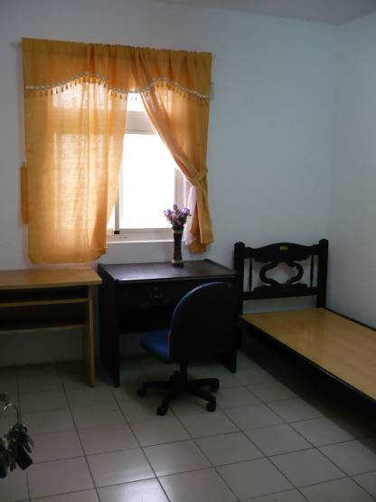
Address： | No.408, Wuxing Rd., Zhongli City, Taoyuan County 320
Contact Info： | missed
Apartment Type：studio |  | Size：142 Sq Ft
Rent： $13,000-18,000 for 6-month
utilities not included
Deposit：$3,000 |  | Lease：missed
- Security System Rentals
■Access Control ■Fire EX. ■Emergency Light ■Monitoring System

- Amenities
■water heater □TV ■Refrigerator ■Air-Conditioner □Clothes Closet □Bedstead
□Bookshelves □Desk & Chair □Desk Lamp ■Cable TV □Telephone
□Windows

- Public Facilities
■Clothes Drying Field ■Parking Spaces for Scooters ■Parking Lot/Garage
□Elevator □Common Room ■Water Dispenser
■Washing Machine □Spin Dryer ■Tumble Dryer □kitchen

