NCU Off-Campus Housing Information
- photos
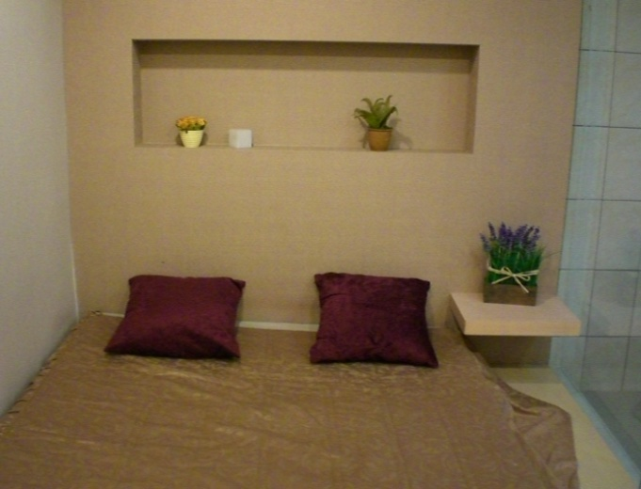 |  |  | 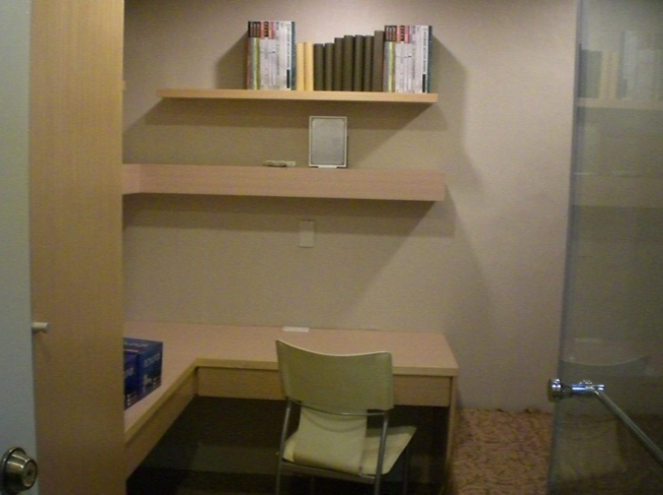
Address： | No.406, Wuxing Rd., Zhongli City, Taoyuan County 320
Contact Info： | Ms. YEH(葉日華) 03-317-3946 / 0931-394-091 / 0935-139-072
Apartment Type：studio |  | Size：178-355 Sq Ft
Rent： $5,000 / month
utilities not included
Deposit：equal to 2-month rent |  | Lease：missed
- Security System Rentals
■Access Control ■Fire EX. ■Emergency Light ■Monitoring System

- Amenities
■water heater ■TV ■Refrigerator ■Air-Conditioner ■Clothes Closet ■Bedstead
□Bookshelves ■Desk & Chair ■Desk Lamp ■Cable TV □Telephone
□Windows

- Public Facilities
■Clothes Drying Field □Parking Spaces for Scooters □Parking Lot/Garage
□Elevator □Common Room ■Water Dispenser
■Washing Machine □Spin Dryer ■Tumble Dryer □kitchen

