NCU Off-Campus Housing Information
- photos
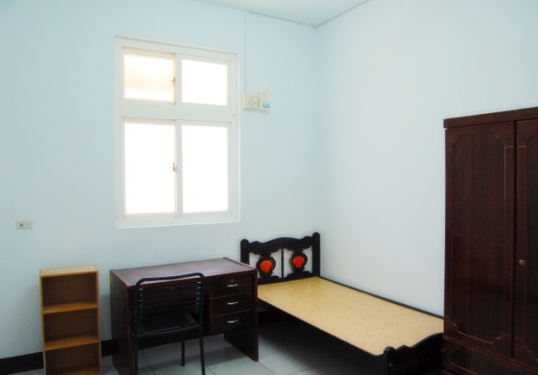 |  |  | 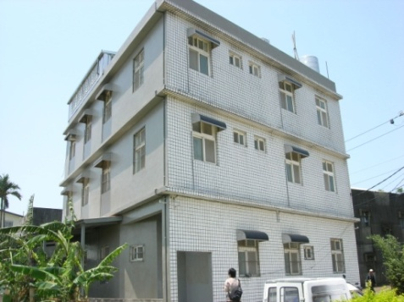
Address： | No.102, Ln. 270, Wuxing Rd., Zhongli City, Taoyuan County 320
Contact Info： | Mr. LIN(林有清) 03-492-4993 / 0910-153-928
Apartment Type：studio |  | Size：178 Sq Ft
Rent： $15,000-23,000 for 6-month
utilities not included
Deposit：$3,000 |  | Lease：missed
- Security System Rentals
■Access Control ■Fire EX. ■Emergency Light ■Monitoring System

- Amenities
■water heater □TV □Refrigerator ■Air-Conditioner ■Clothes Closet ■Bedstead
■Bookshelves ■Desk & Chair ■Desk Lamp ■Cable TV ■Telephone
■Windows

- Public Facilities
■Clothes Drying Field ■Parking Spaces for Scooters □Parking Lot/Garage
□Elevator ■Common Room ■Water Dispenser
■Washing Machine ■Spin Dryer ■Tumble Dryer □kitchen

