NCU Off-Campus Housing Information
- photos
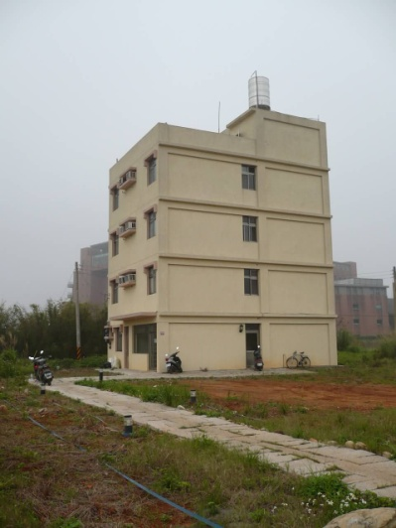
Address： | No.15, Ln. 257, Wuxing Rd., Zhongli City, Taoyuan County 320
Contact Info： | Mr. PENG(彭先生) 03-469-0198
Apartment Type：missed |  | Size：missed
Rent： missed

Deposit：missed |  | Lease：missed
- Security System Rentals
□Access Control □Fire EX. □Emergency Light □Monitoring System

- Amenities
■water heater □TV □Refrigerator ■Air-Conditioner ■Clothes Closet ■Bedstead
□Bookshelves ■Desk & Chair □Desk Lamp □Cable TV □Telephone
□Windows

- Public Facilities
□Clothes Drying Field □Parking Spaces for Scooters □Parking Lot/Garage
□Elevator □Common Room ■Water Dispenser
■Washing Machine □Spin Dryer □Tumble Dryer □kitchen

