NCU Off-Campus Housing Information
- photos
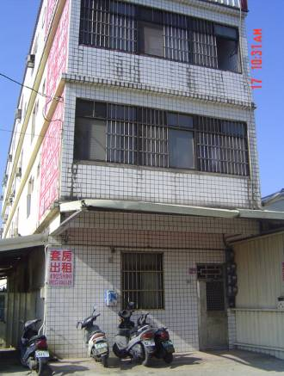 |  |  | 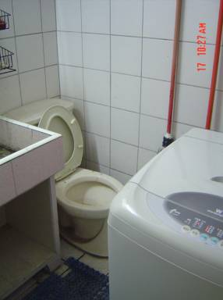
Address： | No.189, Wuxing Rd., Zhongli City, Taoyuan County 320
Contact Info： | Mr. LU(呂道生) 03-492-5890 / 0937-404-149
Apartment Type：studio |  | Size：160 Sq Ft
Rent： missed
utilities not included
Deposit：$5,000 |  | Lease：missed
- Security System Rentals
□Access Control ■Fire EX. ■Emergency Light ■Monitoring System

- Amenities
■water heater ■TV ■Refrigerator ■Air-Conditioner ■Clothes Closet ■Bedstead
□Bookshelves □Desk & Chair □Desk Lamp ■Cable TV □Telephone
□Windows

- Public Facilities
□Clothes Drying Field ■Parking Spaces for Scooters □Parking Lot/Garage
□Elevator □Common Room ■Water Dispenser
■Washing Machine □Spin Dryer □Tumble Dryer □kitchen

