NCU Off-Campus Housing Information
- photos
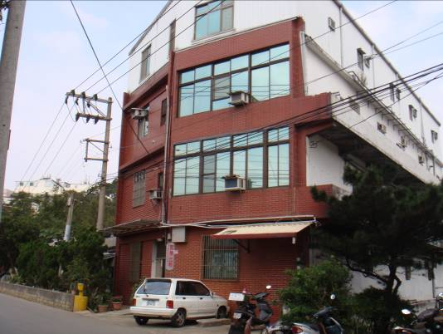 |  |  | 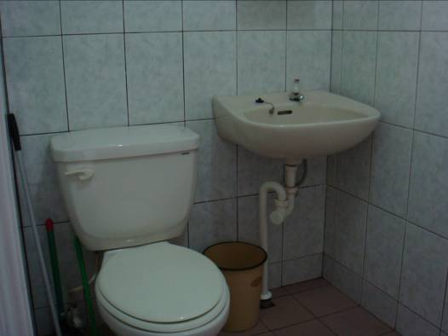
Address： | No.336, Wuxing Rd., Zhongli City, Taoyuan County 320
Contact Info： | Mr. HSU(徐茂斌) 03-491-9099 / 0932-170-855
Apartment Type：studio |  | Size：142-213 Sq Ft
Rent： $21,000 / semester
utilities not included
Deposit：$6,000 |  | Lease：missed
- Security System Rentals
□Access Control ■Fire EX. □Emergency Light □Monitoring System

- Amenities
■water heater □TV □Refrigerator ■Air-Conditioner ■Clothes Closet ■Bedstead
□Bookshelves ■Desk & Chair □Desk Lamp ■Cable TV □Telephone
□Windows

- Public Facilities
□Clothes Drying Field □Parking Spaces for Scooters □Parking Lot/Garage
□Elevator □Common Room □Water Dispenser
■Washing Machine □Spin Dryer □Tumble Dryer □kitchen

