NCU Off-Campus Housing Information
- photos
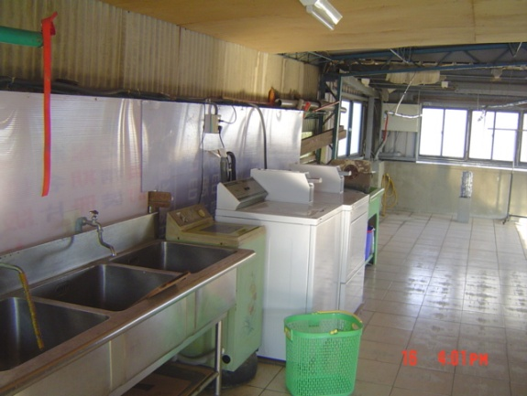 |  |  | 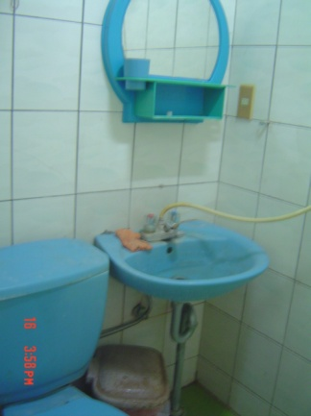
Address： | No.343, Wuxing Rd., Zhongli City, Taoyuan County 320
Contact Info： | Ms. HUNG(洪良柏) 03-490-2919
Apartment Type：studio |  | Size：missed
Rent： $22,000 / semester
utilities not included
Deposit：missed |  | Lease：missed
- Security System Rentals
□Access Control ■Fire EX. ■Emergency Light □Monitoring System

- Amenities
■water heater □TV □Refrigerator ■Air-Conditioner ■Clothes Closet ■Bedstead
□Bookshelves ■Desk & Chair □Desk Lamp ■Cable TV □Telephone
□Windows

- Public Facilities
□Clothes Drying Field □Parking Spaces for Scooters ■Parking Lot/Garage
□Elevator □Common Room ■Water Dispenser
■Washing Machine ■Spin Dryer □Tumble Dryer □kitchen

