NCU Off-Campus Housing Information
- photos
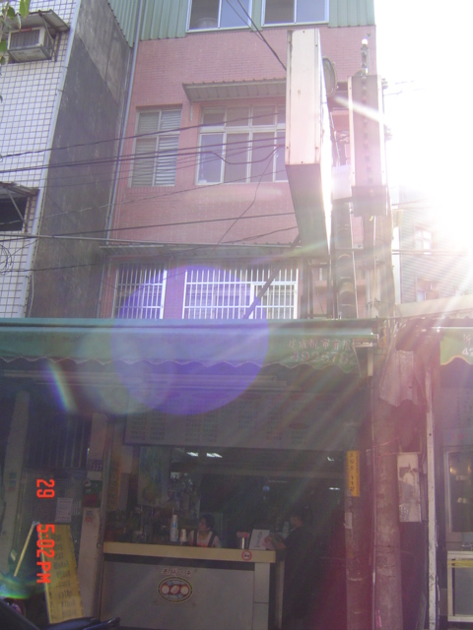
Address： | No.337, Wuxing Rd., Zhongli City, Taoyuan County 320
Contact Info： | Ms. LEE(李玟松) 0911-990-338
Apartment Type：studio |  | Size：178-249 Sq Ft
Rent： $18,000-25,000 for 6-month
utilities not included
Deposit：missed |  | Lease：missed
- Security System Rentals
□Access Control □Fire EX. □Emergency Light ■Monitoring System

- Amenities
■water heater □TV □Refrigerator ■Air-Conditioner ■Clothes Closet ■Bedstead
□Bookshelves ■Desk & Chair □Desk Lamp ■Cable TV □Telephone
□Windows

- Public Facilities
■Clothes Drying Field □Parking Spaces for Scooters □Parking Lot/Garage
□Elevator □Common Room ■Water Dispenser
■Washing Machine □Spin Dryer ■Tumble Dryer □kitchen

