NCU Off-Campus Housing Information
- photos
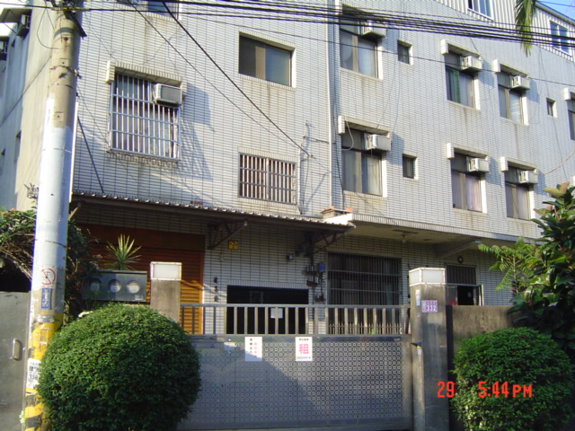
Address： | No.332, Wuxing Rd., Zhongli City, Taoyuan County 320
Contact Info： | Ms. HUANG(黃小姐) 0921-408-008
Apartment Type：studio |  | Size：142-178 Sq Ft
Rent： $15,000-20,000 for 6-month
utilities not included
Deposit：$2,000 |  | Lease：missed
- Security System Rentals
■Access Control ■Fire EX. ■Emergency Light ■Monitoring System

- Amenities
■water heater □TV □Refrigerator ■Air-Conditioner ■Clothes Closet ■Bedstead
□Bookshelves ■Desk & Chair □Desk Lamp ■Cable TV □Telephone
□Windows

- Public Facilities
■Clothes Drying Field ■Parking Spaces for Scooters ■Parking Lot/Garage(charge)
■Elevator □Common Room ■Water Dispenser
■Washing Machine ■Spin Dryer ■Tumble Dryer □kitchen

