NCU Off-Campus Housing Information
- photos
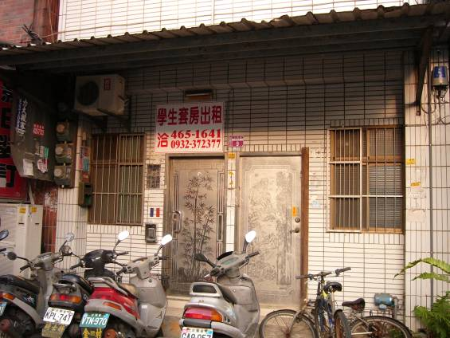
Address： | No. 9, Ln. 331, Wuxing Rd., Zhongli City, Taoyuan County 320
Contact Info： | Mr. Yu (余房東) 0972-228-999
Apartment Type：studio |  | Size：213-249 Sq Ft
Rent： $3,500 / month
utilities not included
Deposit：$3,000 |  | Lease：missed
- Security System Rentals
■Access Control ■Fire EX. ■Emergency Light □Monitoring System

- Amenities
■water heater □TV □Refrigerator ■Air-Conditioner ■Clothes Closet ■Bedstead
□Bookshelves ■Desk & Chair □Desk Lamp ■Cable TV □Telephone
□Windows

- Public Facilities
□Clothes Drying Field ■Parking Spaces for Scooters □Parking Lot/Garage
□Elevator □Common Room ■Water Dispenser
■Washing Machine □Spin Dryer ■Tumble Dryer □kitchen

