NCU Off-Campus Housing Information
- photos
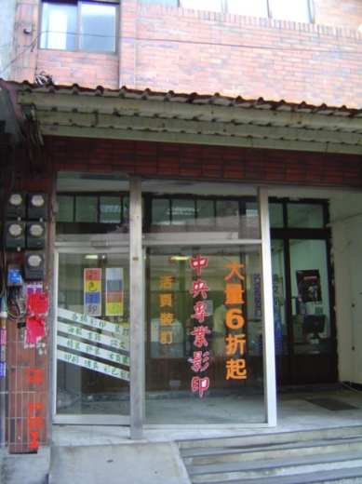 |  |  | 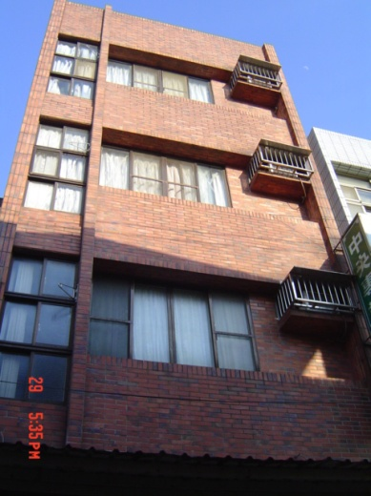
Address： | No.7, Ln. 331, Wuxing Rd., Zhongli City, Taoyuan County 320
Contact Info： | Mrs. YU(余太太) 0988-090-666
Apartment Type：studio |  | Size：213-248 Sq Ft
Rent： $19,000-23,000 for 6-month
utilities not included
Deposit：missed |  | Lease：missed
- Security System Rentals
□Access Control □Fire EX. □Emergency Light □Monitoring System

- Amenities
■water heater □TV □Refrigerator ■Air-Conditioner ■Clothes Closet ■Bedstead
□Bookshelves ■Desk & Chair □Desk Lamp □Cable TV □Telephone
□Windows

- Public Facilities
■Clothes Drying Field □Parking Spaces for Scooters □Parking Lot/Garage
□Elevator □Common Room ■Water Dispenser
■Washing Machine □Spin Dryer ■Tumble Dryer □kitchen

