NCU Off-Campus Housing Information
- photos
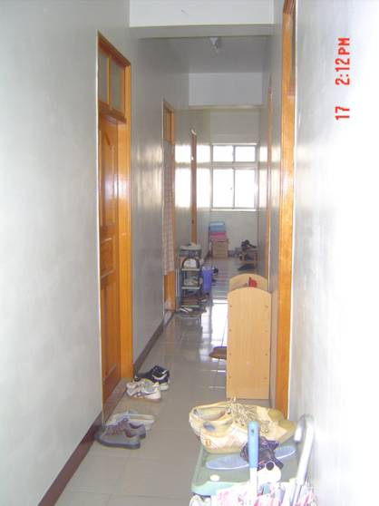 |  |  | 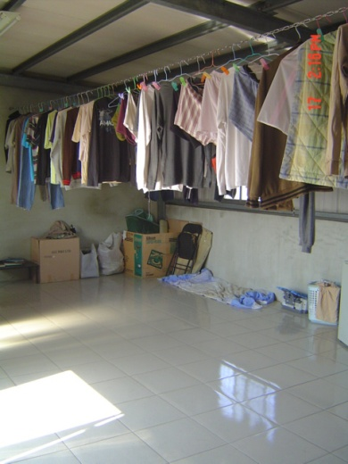
Address： | No.7, Ln. 270, Wuxing Rd., Zhongli City, Taoyuan County 320
Contact Info： | Mr. HSIEH (謝光靈) 03-493-0102 / 03-4931542 / 0933-961-353
Apartment Type：studio |  | Size：178-213 Sq Ft
Rent： $22,000 / semester
utilities not included
Deposit：missed |  | Lease：missed
- Security System Rentals
■Access Control ■Fire EX. ■Emergency Light ■Monitoring System

- Amenities
■water heater □TV □Refrigerator ■Air-Conditioner ■Clothes Closet ■Bedstead
□Bookshelves ■Desk & Chair ■Desk Lamp ■Cable TV □Telephone
■Windows

- Public Facilities
■Clothes Drying Field □Parking Spaces for Scooters ■Parking Lot/Garage
□Elevator □Common Room ■Water Dispenser
■Washing Machine ■Spin Dryer □Tumble Dryer □kitchen

