NCU Off-Campus Housing Information
- photos
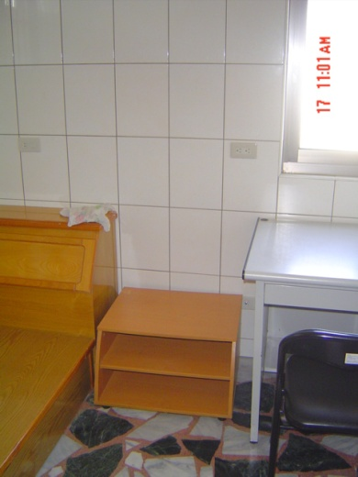 |  |  | 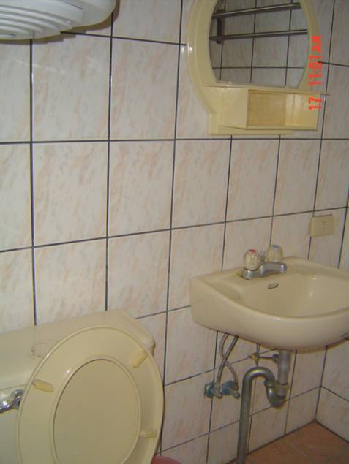
Address： | No.290, Wuxing Rd., Zhongli City, Taoyuan County 320
Contact Info： | Mr. Wang(王房東) 0932-102-259
Apartment Type：studio |  | Size：160 Sq Ft
Rent： $21,000 / semester
utilities not included
Deposit：$3,000 |  | Lease：missed
- Security System Rentals
■Access Control ■Fire EX. □Emergency Light ■Monitoring System

- Amenities
■water heater □TV □Refrigerator ■Air-Conditioner ■Clothes Closet ■Bedstead
□Bookshelves ■Desk & Chair □Desk Lamp ■Cable TV □Telephone
□Windows

- Public Facilities
■Clothes Drying Field ■Parking Spaces for Scooters □Parking Lot/Garage
□Elevator ■Common Room □Water Dispenser
■Washing Machine □Spin Dryer ■Tumble Dryer □kitchen

